5G/6G- COMMUNICATION SYSTEM
CO3 - ASSESSMENT TOOL 2
NAME: Allu Thanmai
REG .NO : 192412616
SLOT A

- Design a system architecture for Multi-access Edge Computing to reduce latency in
smart traffic applications. (BL6)

Aim:
To design and simulate a Multi-access Edge Computing (MEC) architecture that minimizes communication latency in smart traffic applications by processing data at the network edge instead of sending it to a centralized cloud.

Procedure:

- Define the number of smart traffic sensors and vehicles.

- Generate different network loads.

- Calculate cloud latency based on network load.

- Calculate MEC latency considering local edge processing.

- Compare cloud latency and MEC latency.

- Plot the latency comparison graph.

- Analyze the improvement achieved using MEC.

MATLAB Code:
clc;
clear;
close all;

% Number of vehicles
vehicles = 10:10:100;

% Cloud latency (ms)
cloud_latency = 80 + 0.6*vehicles;

% MEC latency (ms)
mec_latency = 20 + 0.2*vehicles;

figure;

subplot(2,1,1)
plot(vehicles, cloud_latency,'-o','LineWidth',2)
grid on
xlabel('Number of Vehicles')
ylabel('Latency (ms)')
title('Cloud Latency')

subplot(2,1,2)
plot(vehicles, mec_latency,'-s','LineWidth',2)
grid on
xlabel('Number of Vehicles')
ylabel('Latency (ms)')
title('MEC Latency')

OUTPUT:

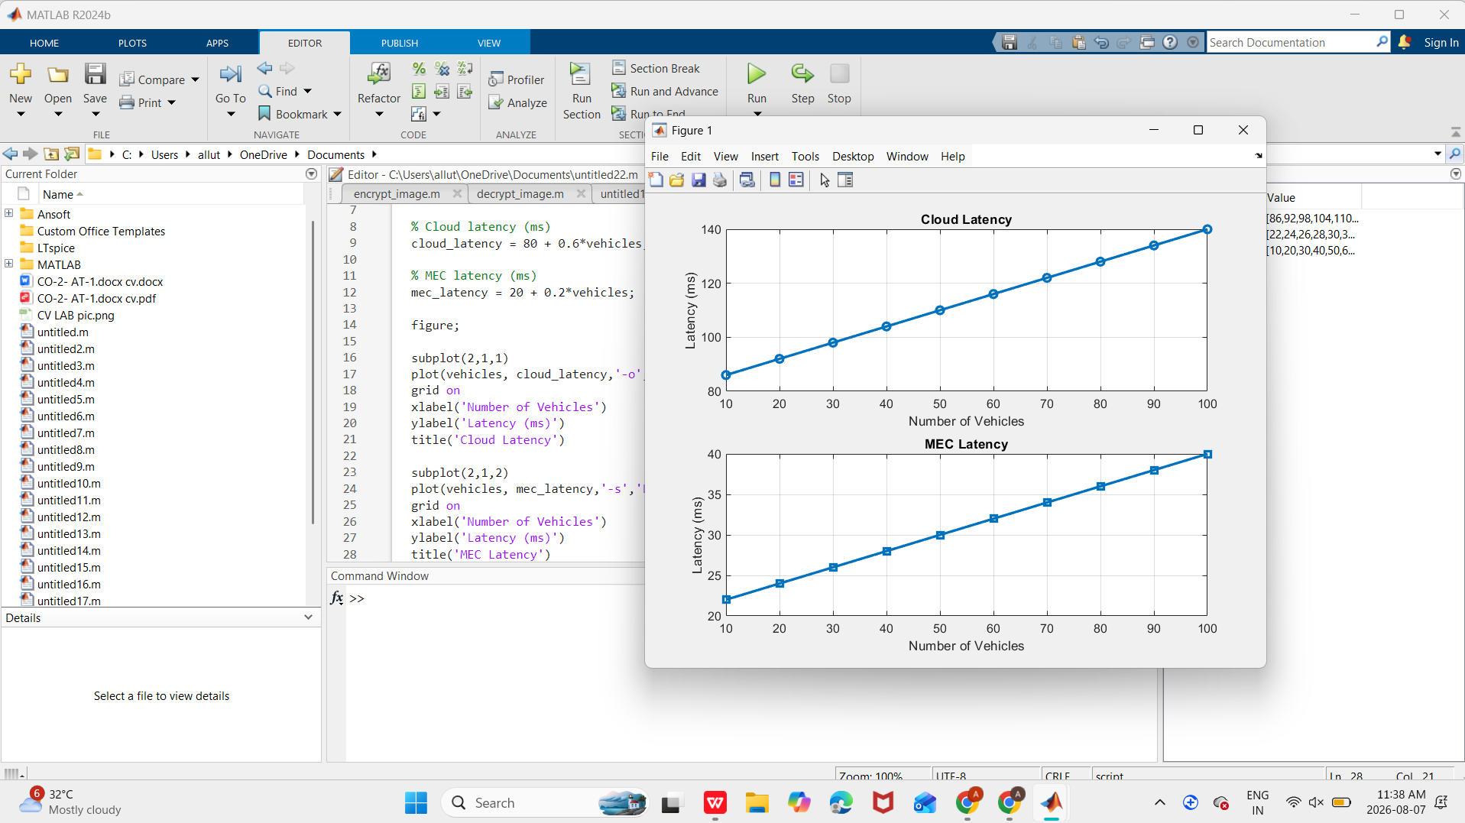

Result:

The simulation shows that the MEC architecture significantly reduces communication latency compared to cloud computing. Processing data at the edge enables faster traffic decisions and improves the performance of smart traffic management systems.

- Develop a cloud-edge communication model for wireless healthcare monitoring. (BL6)

Aim:

To develop and simulate a cloud-edge communication model for wireless healthcare monitoring that reduces response time while ensuring reliable transmission of patient health data.

Procedure:

- Initialize different patient monitoring nodes.

- Generate patient health data.

- Calculate cloud communication delay.

- Calculate edge communication delay.

- Compare both delays.

- Plot communication delay graphs.

- Analyze the performance improvement using edge computing

MATLAB Code:

clc;
clear;
close all;

% Number of patients
patients = 5:5:50;

% Cloud delay (ms)
cloud_delay = 120 + 0.8*patients;

% Edge delay (ms)
edge_delay = 35 + 0.3*patients;

figure;

subplot(2,1,1)
plot(patients,cloud_delay,'-o','LineWidth',2)
grid on
xlabel('Number of Patients')
ylabel('Delay (ms)')
title('Cloud Communication Delay')

subplot(2,1,2)
plot(patients,edge_delay,'-s','LineWidth',2)
grid on
xlabel('Number of Patients')
ylabel('Delay (ms)')
title('Edge Communication Delay')

OUTPUT:

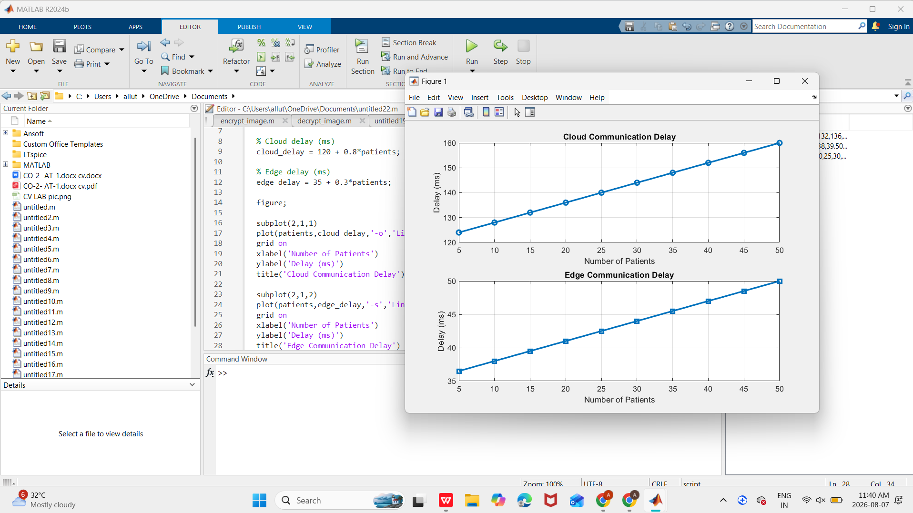

Result:

The cloud-edge communication model demonstrates that edge computing provides lower communication delay than cloud-only processing. This enables real-time monitoring of patient health data, making the system more suitable for emergency healthcare applications.

